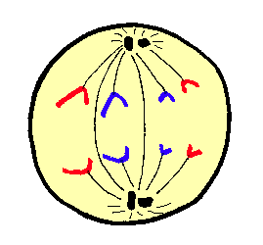
Mitosis & Meiosis Slideshow
Presentation Script

You will be creating slideshows with visual and audio explanations of the various phases of mitosis and meiosis to demonstrate how they differ from one another. Use the organizer below to plan out what your slides are going to show and what you are going to say for each slide.

Draw what your slide will Write the explanation of what is happening in each
show here phase here to say aloud
SLIDE 1
SLIDE 2
SLIDE 3
SLIDE 4
SLIDE 5
SLIDE 6

